Ticket #103: RLS Authorisation
  - What I built, how I tested it, and what is still outside this ticket
GitHub Issue #103 | Date: 11 October 2026 | Branch: feature/M3-BE-02-rls-authorisation
Code: supabase/migrations/20261011051521_m3_be_02_rls_authorisation.sql

1. Why this document exists
This document explains the security rules I added to CivicConnect, the tests I ran in Supabase, and the limitations that belong to other work. The SQL migration is the actual code; the screenshots show the results of testing that code.
Authorisation simply means deciding who is allowed to see or change information. CivicConnect must enforce those rules in the database, not only by hiding buttons on the website.

A simple example
Requester A submitted RLS-TEST-A and Requester B submitted RLS-TEST-B. Each requester should only see their own request. Staff A should see Request A because it was assigned to them. Managers and administrators may read both.

Two terms worth knowing
- RLS (Row Level Security): database rules that decide which individual records a user may access.
- Database permission (GRANT): a rule allowing an operation such as SELECT (read), INSERT (create) or UPDATE (change). An RLS rule does not automatically grant permission to update.

2. What I implemented
- Enabled RLS on all 12 public tables in the proposed database schema. Anonymous users were not granted direct read access to any of them.
- Requesters can view their own requests and create new requests under their own account. They cannot create a request for another requester or assign staff during creation.
- Ordinary staff can read requests currently assigned to them. Active managers and administrators can read all requests.
- Related records are protected: request history and public comments follow request visibility; internal comments require authorised staff access; requester contact details remain owner-only.
- Direct updates and changes to protected workflow tables remain blocked. The later assignment and status-workflow tickets will implement controlled changes and history logging.
- Five further sensitive tables—status transitions, channel messages, attachments, notifications and audit log—are closed to direct application access until relevant features and permissions are defined.

3. Who can access what?
User | Allowed now | Not available through #103
Requester | Own requests and contacts; public comments/status history on own requests; create a request for self | Cannot change assignment or status directly
Staff | Personally assigned requests; related allowed comments, history and assignment records | No permanent direct request UPDATE permission
Supervisor | Personally assigned requests only | No team-wide access: there is no team-membership structure
Manager | All requests and related allowed comments/history | Reports are not built; no unrestricted direct writes
Administrator | All requests and related allowed comments/history | User management and assignment operations are not built here
Anonymous | No direct read access to the 12 public tables | No application table access granted

Note: The current contact policy does not give staff, managers or administrators direct access to requester-contact records.

4. How I verified the rules
Testing was performed in local Supabase Studio (not a hosted database). I created two test requests and five test accounts, then simulated each signed-in account in SQL. I compared the records returned with the records each user should be allowed to see.
Check | What it demonstrated | Result
Request visibility | Requesters saw only their own requests; Staff A saw assigned A; manager/admin saw A and B | 5 / 5 PASS
Related data | Expected comments, status history, assignments and requester contacts for each of five identities | 5 / 5 PASS
Direct writes | Protected table INSERT privileges and direct service-request UPDATE permission are not granted | 1 / 1 PASS
Table configuration | RLS enabled on all 12 public tables | 12 / 12
Anonymous reading | No public table has an anonymous SELECT grant | 0 / 12 granted
Clean local reset | RLS migration applied after proposed schema migrations | PASS*

*The full clean reset succeeded only after disabling 12 broken audit-trigger declarations in the isolated sandbox copy (explained in Section 6). The unchanged proposed audit migration was not proven to work.
The 6/6 final result means five user tests plus one database write-permission test. Earlier negative tests (for example, trying to create a request under the wrong owner) are preserved in the screenshot folder but were not all repeated in that final six-row script.

5. Actual Supabase screenshots
These pictures are the original Supabase Studio results from the final tests. They are not recreated tables or typed claims.

Screenshot A — Request visibility: all five users PASS
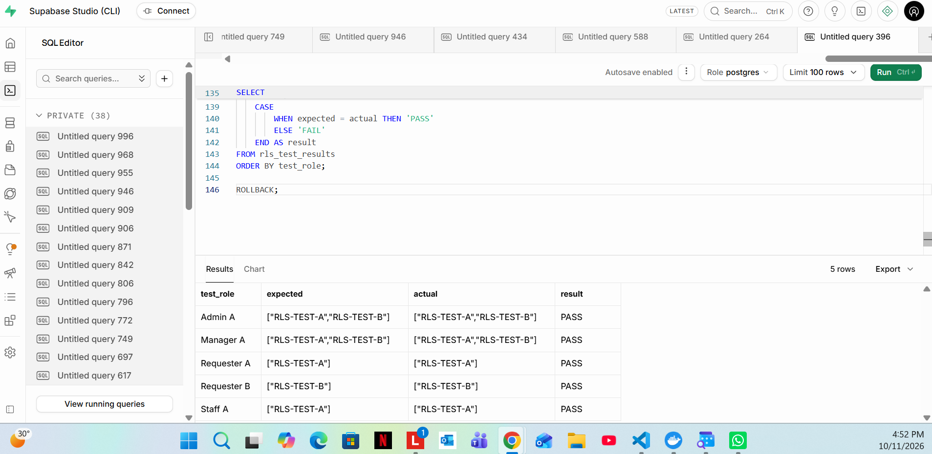
Supabase Studio: requester A only A, requester B only B, staff A assigned A, manager/admin A and B.

Screenshot B — Comments, history, assignments, contacts and write permissions: six PASS
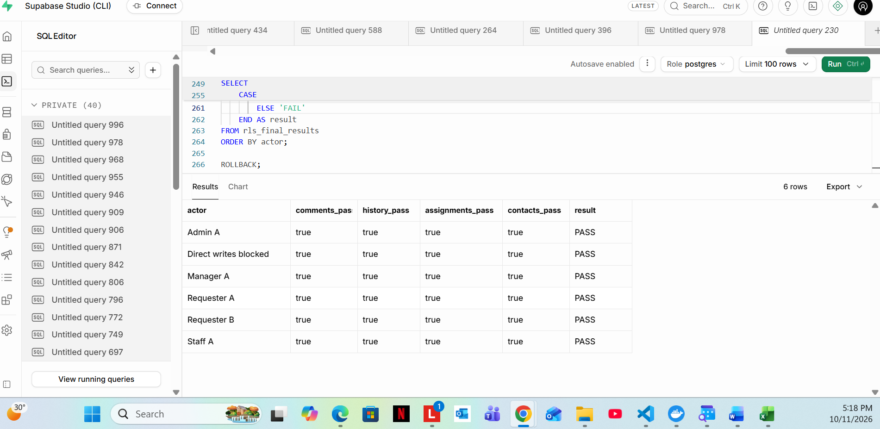
Supabase Studio: all five test identities and the direct-write permission check passed.

6. What is still undefined or outside Ticket #103?
Item | Plain-language explanation
Supervisor team structure | The current schema has no way to identify which staff belong to a supervisor. Only personally assigned requests are available to supervisors.
Assignments (Issue #106) | Accepting, assigning and reassigning requests still needs a backend operation. #103 protects access but does not build it.
Status workflow (Issue #107) | The team has not supplied an approved list of valid status changes. Changing status and automatically recording history are handled by #107.
Admin/management features | Admin user-management operations and manager reports are not part of the RLS migration.
Audit migration error | Upstream 007_audit_log.sql calls a missing public.audit_row() function. To finish local testing, 12 broken audit triggers were temporarily disabled only in the sandbox copy.
Migration dependency | The #103 migration needs the tables proposed in PR #112 to exist first. A sandbox PASS does not prove the unchanged PR #112 audit migration deploys cleanly.

These points are documented for clarity. They are not promises that the author must reopen #103 or implement other tickets.

7. What the result means
The verified local tests show that the implemented RLS policies restrict request visibility and supporting information as intended, and block the specified direct writes. They do NOT prove that the full website authentication flow, unfinished workflow functions, or original audit migration are complete.
Submission status: The migration, screenshot evidence and this report are ready for final Git review; the branch has not yet been committed or merged. Next: review the files, commit only #103 deliverables and open the PR to staging.

Evidence locations in the repository
- Main SQL: supabase/migrations/20261011051521_m3_be_02_rls_authorisation.sql
- Original images: evidence/M3-BE-02/screenshots/
- Final CSV: evidence/M3-BE-02/final-access-results.csv
- Issue #103: github.com/RyanTPH/CivicConnect/issues/103; pending schema PR #112: github.com/RyanTPH/CivicConnect/pull/112

